Transforming your network with SD-WAN:

Connect with savings and better performance

Transforming your network with SD-WAN: Connect with savings and better performance

Meeting today’s wide area network challenges

In this white paper, we will look at the increasingly complex demands most organizations face in securely and efficiently handling growing wide area network traffic between their data centers, main offices, branches and remote workers. We will also share insights on the evolving software-defined WAN (SD-WAN) solutions to resolve these network challenges and detail how Dell IT analyzed its network traffic, selected and deployed an SD-WAN solution and gained efficiencies and increased capacity to meet new network demands.

Transforming your network with SD-WAN: Connect with savings and better performance

Table of contents

Traditional WAN is obsolete 4

Dell Digital use case 5

Lower costs, increased efficiency with Virtual Edge Platform 4600 6

Why VMware SD-WAN? 7

VMware SD-WAN Orchestrator 8

VMware SD-WAN Gateway 9

SD-WAN gains exceed expectations 10

.

# Traditional WAN is obsolete

Expecting a traditional wide area network (WAN) to handle today’s Internetheavy traffic is like using a single-lane country road system to handle the crush of cars during metropolitan rush hour. It just doesn’t let users get where they need to go in a fast and efficient way.

Yet many organizations are still struggling with rising costs and capacity demands of a traditional WAN, in which the onslaught of Internet traffic is backhauled through their data centers across costly Multiprotocol Label Switching (MPLS)—the traditional premium price transport procured from major telecom carriers. It is then sent through firewalls to the Internet.

Traditional WAN was designed for a time when a typical worker used the network predominantly for applications hosted in an organization’s data centers. Back then, if a user was in a branch office, everything he or she needed, from email to financial applications to HR services, was hosted in the data center. Users connected via MPLS, which was tried and true, proven and had very high SLAs. Connecting to the Internet was treated as untrusted traffic and was hosted outside data center locations with security infrastructure around it.

|  |
| --- |
| The challenge is choosing the right solution that will align with your organization’s business objectives, your applications disposition, and the right partners. |

With the rise of Software-as-a-Service applications and Infrastructure-as-aService to manage workloads—along with increased personal web use by employees—network traffic has shifted dramatically. Over the past few years, the increased capacity demands of Internet-bound traffic has continued to grow exponentially.

Not only are costs ballooning to send all that Internet traffic through a data center via MPLS, the volume also requires IT operations to scale infrastructure to keep pace. What’s more, to safeguard performance of business-critical traffic in the face of skyrocketing Internet traffic, IT has had to set guardrails on SaaS applications, reducing speed and quality and eroding user experience.

Traditional WAN has become impractical and ineffective. What is needed is a mix of network options, including more Internet-based transport.

A growing array of SD-WAN solutions over the past several years promises to achieve that mix by applying software-defined technology to the network to direct growing network traffic in a way that makes sense. SD-WAN uses software to control the connectivity, management and services between data centers and remote branches or cloud instances.

The challenge in this still-evolving market, is choosing the right solution that will align with your organization’s business objectives, your applications disposition, and the right partners to make it successful.

# Dell Digital use case

Dell Digital, Dell’s IT organization, started investigating how to modernize our WAN several years ago in the wake of Dell’s acquisition of EMC Corporation. Each company had separate traditional WAN systems supporting hundreds of thousands of employees. Growing Internet traffic from our branch sites due to increased cloud application use

was putting pressure on our business-critical transport and increasing MPLS costs. Dell’s traditional WAN linked 218 branches, main offices, factories, data centers as well as remote workers,

An analysis showed that some 70 percent of our network traffic had shifted to being linked to the Internet. All Internet traffic from remote sites was passing through our data centers via MPLS lines.

We began reviewing SD-WAN offerings but found most lacked the maturity to be production-ready for an enterprise the size and scale of Dell. Not only was the technology still very raw but many SD-WAN companies were small, venturecapital-backed startups. They were not production-ready for a large enterprise and had not yet partnered with the major telecommunication carriers who would later prove vital to their success.

Two years later, in 2018, however, our Global Network Services Site Connectivity team concluded the market had sufficiently matured to take on the transition. It was in the midst of an independent analysis of SD-WAN providers,

with several vendor solutions set up in our lab environment, when Dell-owned VMware acquired one of its top choices —VMware SD-WAN.

Its addition to the VMware portfolio, combined with the fact that Dell EMC had develop a purpose-built hardware box called the Dell EMC Networking Virtual Edge Platform (VEP4600) exactly suited to provide the foundation for virtualizing network functions at lower cost, set the stage for the SD-WAN transition using Dell on Dell technology. The VMware SDWAN and VP4600 were coupled with VMware vSphere ESXi, the orchestration layer.

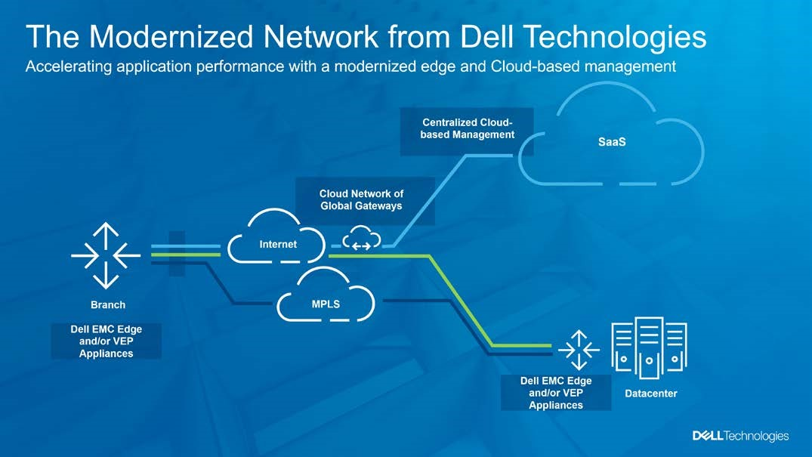

# Lower costs, increased efficiency with Virtual Edge Platform 4600

Dell leveraged its strong history in the server market to develop a hardware platform for networking, purpose-built for

SD-WAN running what we call virtual network functions. The VEP4600, a universal customer premise equipment device (uCPE), utilizes the Intel Xeon100 chip set, a processor innovation that accelerated the switching and routing of network traffic.

Intel’s Quick Assist accelerated encryption and compression of packets and its Data Plane Development Kit (DPDK) greatly boosted packet processing performance. That meant VEP4600 could compete with traditional routers and switches, which had previously been the fastest way to switch or route traffic.

This allowed Dell Digital to replace its traditional Cisco routers across its network at a considerable cost benefit.

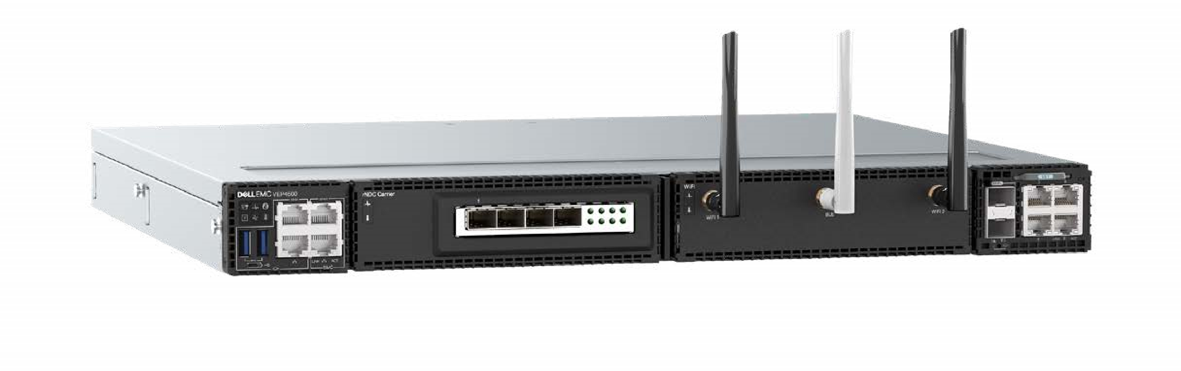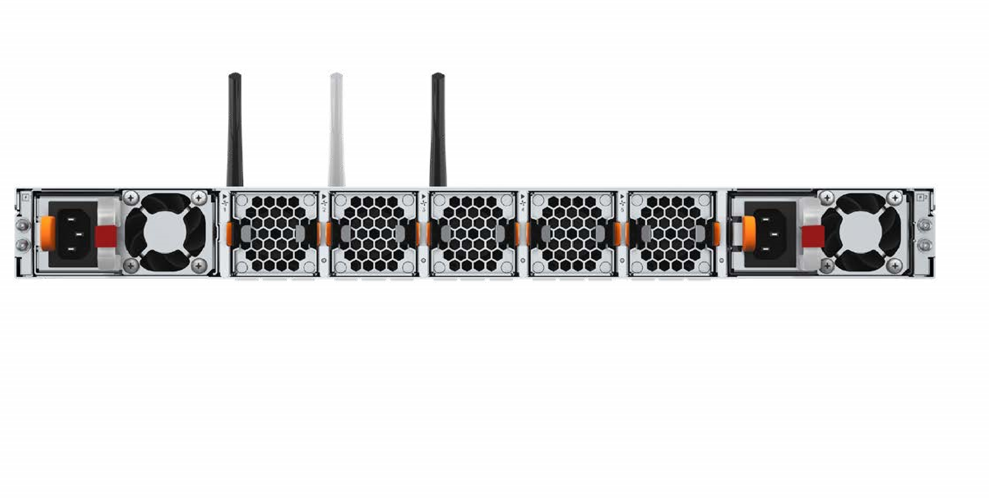

Deploying VEP4600 also addressed inefficiencies that had arisen around varying requirements and features of different Cisco routers that made up our network over the years. The routers throughout our system had differences in terms of physical hardware, software, and code versions based on when the sites they served became live. This so-called

“code drift” caused inefficiencies because different versions of code had different vulnerabilities, different feature sets, or different bugs that had to be dealt with.

VEP4600 is capable of hosting multiple virtual network functions, including the VMware SD-WAN Edge.

Overall, the switch to VEP4600 allowed us to run multiple workloads efficiently and be ready for future growth opportunities.

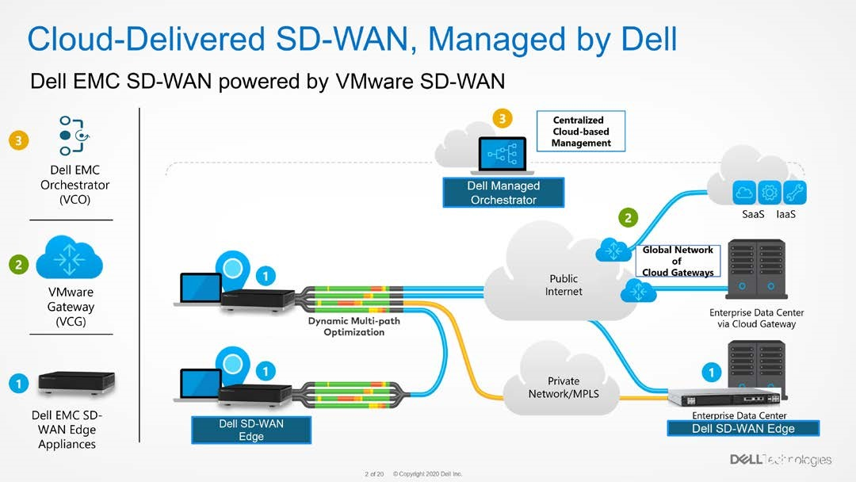

# Why VMware SD-WAN?

The VMware SD-WAN solution offers game-changing capabilities that made it stand out in our analysis of SD-WAN options—specifically the modern, purpose-built networking appliances; the software’s cloud-based management and global gateways that provide faster access to cloud applications.

VMware SD-WAN is essentially three components: the VMware SD-WAN Orchestrator, which provides central management configuration and monitoring; VMware SD-WAN Gateway, a unique global network of cloud connections; and VMware SD-WAN Edge, purpose-built hardware appliances including VEP4600.

Centrally controlled by the orchestrator and hosted on VEP hardware, the VMware SD-WAN solution delivers virtual services, including cloud VPN, overlay control, security and application performance monitoring.

While the main components all offer important distinguishing capabilities, one solution service feature was a key differentiator in Dell Digital’s analysis—the platform’s “secret sauce,” VMware SD-WAN Dynamic Multipath Optimization™ (DMPO). The DMPO provides per packet monitoring across the network to instantly detect and correct performance issues by steering transports to the optimum path across all network circuits.

With legacy WAN, while a network might have multiple circuits, including dual MPLS carriers, they are not all active at once. Traditional WANs have an active-passive topology, meaning a secondary MPLS circuit would only activate if the primary circuit failed.

With DMPO, all circuits across the network—whether multiple MPLS carrier circuits or Internet-based connections, cable modem or satellite links—are fully utilized in an active state, making all bandwidth available. Across that bandwidth, DMPO provides real-time monitoring of all application performances and steers application flow to better performing links when needed to maximize connection quality. The flow can be defined by configured policy.

DMPO performs sub-millisecond continuous checks to protect transmission and packet flow. That means if you have a performance issue—a brownout or intermittent glitch from a passing storm or a hard failure— on any circuit, DMPO will correct the problem in real time.

DMPO was a key factor in Dell Digital’s choice of the VMware SD-WAN solution because it addresses the challenge of making sure voice traffic is of the quality needed to support Dell’s contact center agents so critical to sales, service and finances.

# VMware SD-WAN Orchestrator

The VMware SD-WAN Orchestrator, a cloud-hosted centralized management system which provides a single, paneof-glass view of end user devices, was another differentiator over other SD-WAN offerings. It offers significantly more reporting capabilities than other providers Dell Digital was considering for its transition. It also provides visibility into application performance and aids in troubleshooting.

Overall, the Orchestrator defines how data flows into and through the SD-WAN overlay. More specifically, Orchestrator allows the network to set business policy, offering granular control in terms of routing patterns and how certain devices talk to other devices or are accessed by defined populations.

The VMware SD-WAN Orchestrator is a differentiator over other SD-WAN offerings

It also allows specific control of application traffic, where say, for Office 365 or Exchange Online, you might want that traffic today to come back to your data center, so your cybersecurity team can do more analysis on any traffic.

Once a business policy is created in Orchestrator, you can deploy it to one Edge Platform box, two boxes, a grouping of boxes, or all of our boxes. It allows customized groupings— regionally, state-based, country-based, or however you want to do it.

Orchestrator configures Edge devices via standardized and zero-touch provisioning for deployment in the network without the help of network technologists. This compared to the legacy system where a router had to be shipped to one location to be configured by an engineer, then shipped to the final location to be put physically in place by a technician and then activated via an engineer cutover.

The VEP4600 gets configured at the location at time of turn up, all done remotely via the engineer and Orchestrator. Unlike with traditional routers, Edge device configurations are harmonized so that a box in Israel looks like a box in San Jose.

What’s more, software upgrades to the VMware SD-WAN are standardized, automated and seamless across the system compared with having to upgrade routers one box at a time.

We also use Orchestrator for high-level monitoring of applications or traffic in terms of how the system is performing, and provide alerts,

either from a hardware or software circuit perspective. In response to our request, VMware SD-WAN has matured its features to enable API integration to the other monitoring tools we use around the globe.

We specifically wanted our SD-WAN system to provide alerts that would tie in to the holistic monitoring systems our less technical team members are accustomed to reading so that we wouldn’t need a SD-WAN subject matter expert to understand the alert.

# VMware SD-WAN Gateway

Another important differentiator is VMware SD-WAN Gateway (VCG), a network of points-of-presence and cloud data centers around the world. VMware SD-WAN leveraged its global partnerships to create more than 500 managed colocation facilities which are tied into SaaS providers, so they have direct connections to applications such as Office 365, Google Cloud, Azure, and more.

The gateways offer faster access to SaaS by reducing the number of hops required (locations branch traffic must pass through) to reach a particular SaaS provider. Using legacy topology, a connection with Office 365, for example, would go from a branch office location back to one of our data centers, and then out to the public Internet to eventually reach the app. Or in some cases, if Dell has a private connection to the app, it would go from the branch office location to a data center to our managed connection.

With VCG, that request can go from the branch office to the nearest VCG and then directly to the application.

The primary function of the gateway is to perform SD-WAN control plane functions, including highly scalable route distribution. They also provide an on-demand, scalable, and redundant cloud network for optimized paths to cloud destinations.



# SD-WAN gains exceed expectations

After weighing various provider features and conducting a pilot program to ensure its tie in with Dell’s global network, Dell Digital began a 2019 roll out VMware SD-WAN and VEP4600 coupled with VMware vSphere ESXi, the orchestration layer.

As expected, transitioning to SD-WAN brought cost savings, including a 20 percent saving in annual telecom expenses for Global Network Services due to the reduction of our MPLS footprint.

And as expected, SD-WAN allowed us to improve user experience, particularly for software-as-a-service (SaaS) applications. User survey scores on Internet access and internal network performance have climbed steadily in recent months, exceeding our 70 percent best-in-class ranking.

What we didn’t expect was that the roll out of our software-defined WAN over the past 16 months would be a key factor in our ability to readily scale our global network’s points-of-presence to allow some 120,000 Dell Technologies team members to connect remotely in the face of a worldwide shift to working from home.

The performance and user experience benefits of SD-WAN made all the difference in enabling our employees to work from home right away.

In our migration from legacy MPLS private line connections to Internet connections, we had beefed up our core data centers’ Internet points-of-presence, which is the same environment that supports our VPN platforms crucial for remote connections. Because our Internet environments were increased in size, we were able to handle the full global work from home volume when that need suddenly arose.

Moving forward to modernize the way your company stays connected with the right mix of private carrier and Internet transport just makes sense in today’s

flexible work environment.

Beyond that, we had been improving the performance of our SaaS offerings due to our increased bandwidth and the fact that we were now directing our traffic in the most efficient way. And since SD-WAN provides application visibility, including an evaluation grade on every application, we are able to make informed decisions in terms of how we want to route applications through the network.

Bottom line: we revved up to support our SaaS offerings and other corporate application flows at scale rooted in a common and performant experience whether at an office or remote.

For the past 16 months, Dell IT’s Team Member Experience has been rolling out SaaS collaboration tools—such as OneDrive, Teams and Zoom—to more team members as the locations to which they are connected transformed to SD-WAN.

That meant that most of our team members were already equipped and familiar with these tools so vital to staying connected and productive from home when they had to go remote.

What this underscores is that moving forward to modernize the way your company stays connected with the right mix of private carrier and Internet transport just makes sense in today’s flexible work environment. You can maintain your mission-critical capabilities while accommodating crucial Internet access and efficiency with VMware SD-WAN.